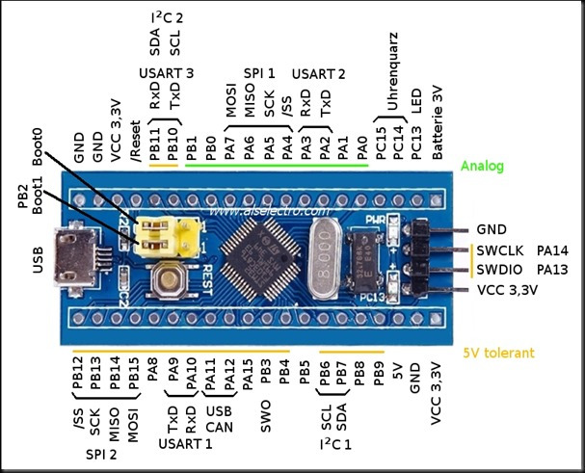

the STM32 Board has to be put into programming mode before uploading any program, to do this put the boot 0 jumper in the 1 position.

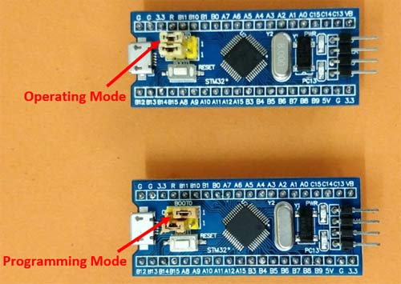

UART1 (PA9, PA10) is used to upload code. For this you need a USB-TTL module .
The Vcc pin of the FTDI module is connected to the STM32 5V pin, The ground to the Ground.
The Rx and Tx pin of the FTDI module is connected to the A9 and A10 pin of the STM32 respectively. Where the A9 is the Tx pin of STM32 MCU and the A10 is Rx pin (A9 and A10 are 5V tollerant).

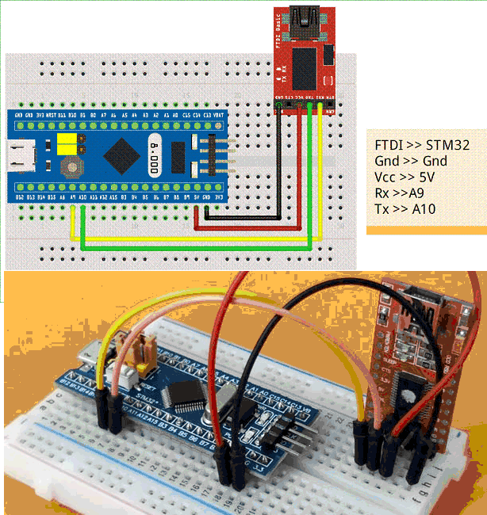

I used YAGARTO to compile the BLINKER program and ST STMFlashLoader Demo (Demonstrator GUI) to load it.

1- connect the blue Pill board to PC via the FTDI ( boot0 pin connected to 3V3 --> 1 ).
2- Press the RESET button.
3- Start STMFlashLoader Demo (demonstrator gui), the COM port is detected and settings done automatically .
else , Select 115200 Baud rate and select the FTDI COM port. Leave all other settings as default.
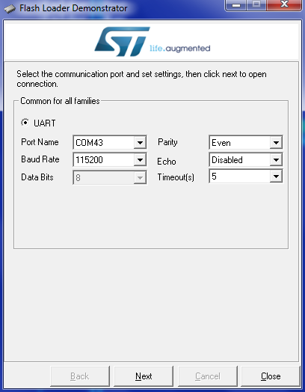

4- Press NEXT and It will automatically detect the blue pill.
5- Press NEXT twice and you’ll be at the window where u can choose file to download into the board
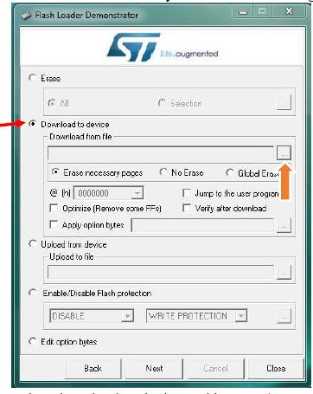
6- Select download to device and select “jump to the user program” and “Verify after download” then browse to select your file.
7- Select Bin Files if the file doesn’t show up. Press Open.
8- Press NEXT the file will be downloaded to Blue pill board. Close demonstrator gui when done.

After uploading the program the boot 0 should be changed back to operating mode so that next time when the Board is powered the uploaded program starts to get executed automatically.

==============================
Install USB bootloader:
Use the previous steps to flash stm32duino bootloader (generic_boot20_pc13.bin)
When the board is connected to PC it'll be deteceted as "maple 003" device, and the LED (PC13) will blink continuously.

NOTE: if u need to reflash the bootloader, in step6 select “Global erase” to erase the chip entirely.

Install dfu driver:
in driver install wizard search for the "Arduino_STM32\drivers\win\maple-dfu" folder and install the driver.

To check if the board is detectable, in a terminal run the command:
dfu-util.exe –list or dfu-util.exe –l

the dfu utility “ dfu-util.exe “ is in the folder “Arduino_STM32\tools\win”

the response will be:

dfu-util - (C) 2007-2008 by OpenMoko Inc.
This program is Free Software and has ABSOLUTELY NO WARRANTY

Found DFU: [0x1eaf:0x0003] devnum=1, cfg=0, intf=0, alt=0, name=""
Found DFU: [0x1eaf:0x0003] devnum=1, cfg=0, intf=0, alt=1, name="STM32duino bootloader v1.0 Upload to Flash 0x8005000"
Found DFU: [0x1eaf:0x0003] devnum=1, cfg=0, intf=0, alt=2, name="STM32duino bootloader v1.0 Upload to Flash 0x8002000"

Flash a program using USB bootloader:
To flash a program for the first time (PC13 LED blinking continuously) invoke dfu-util like this:

Arduino/hardware/Arduino_STM32/tools/win/dfu-util -d 1EAF:0003 -a 2 -D blink.bin -R

where:
-d 1EAF:0003 Specify Vendor/Product ID of blue pill
-a 2 Specify the Alt setting of the DFU Interface (Upload to Flash 0x8002000)
-D blink.bin Write” blink.bin” file into device
-R Issue USB Reset signalling once we're finished

NOTE: the program must be compiled to be loaded at 0x08002000

The response is:

dfu-util - (C) 2007-2008 by OpenMoko Inc.
This program is Free Software and has ABSOLUTELY NO WARRANTY

Opening USB Device 0x1eaf:0x0003...
Found Runtime: [0x1eaf:0x0003] devnum=1, cfg=0, intf=0, alt=2, name="STM32duino bootloader v1.0 Upload to Flash 0x8002000"
Setting Configuration 1...
Claiming USB DFU Interface...
Setting Alternate Setting ...
Determining device status: state = dfuIDLE, status = 0
dfuIDLE, continuing
Transfer Size = 0x0400
bytes_per_hash=4
Starting download: [#######################################################] finished!
state(8) = dfuMANIFEST-WAIT-RESET, status(0) = No error condition is present
Done!
Resetting USB to switch back to runtime mode

Note: after first flashing the bootloader you may have to place the board into "perpetual bootloader" mode before you can upload an arduino sketch; place a 4,7k resistor between pin PC14 and 3.3V, and then reset the board. You should now be able to flash a blank arduino sketch, remove the resistor, and restart the board, after which uploading new sketches should work as expected.
After installing the first sketch open Arduino_STM32 folder>drivers>win and run “install_drivers.bat”, which runs wdi-simple.exe twice, once to install the usb serial device and once to install the DFU device.
Note: This doesn't actually install drivers. Windows (7+) comes pre-installed with a compatible Serial USB driver and a DFU (upload) driver. However the built in drivers need to be associated with the USB ID of the Maple serial and DFU devices. The batch file and wdi-simple.exe do the clever stuff to convince Windows 7 or newer, that it should use its drivers with the Maple serial and DFU devices.
If you get the message " wdi-simple.exe is not a valid Win32 application” install the drivers manually from folder Arduino_STM32/drivers/win/win_xp_legacy/maple-dfu/.. and /maple-serial/...
Aport COM will apperar, use it to upload sketches choose the correct maple COM port in arduino IDE.
usb-serial is actually part of stm32duino libmaple core sketch, making sure SERIAL_USB is defined in the build flags in relevant section in boards.txt
or upload a Blink sketch that also includes Serial.begin and Serial.print .
Unless you load a sketch that uses USB serial, the USB serial device does not always appear.
The latest bootloader includes a dummy sketch, so after it switches from bootloader to sketch it should show up as serial.
When you plug the board in, the LED should flash very quickly 6 times followed by 6 flash (but not as fast) flashes This indicates the bootloader is working.
As the latest bootloader comes with a dummy sketch to test the Serial, after the LED stops flashing the board should switch to the sketch and re-enumerate as a Serial device
Look in the Windows device manager and initially you should see the libusb-win32 device, and after 1 sec, you should see the serial device
If the drivers didnt load, you will see 2 different known devices, one for when the bootloader is running and the other for the sketch Serial

If you find that the ARDUINO IDE successfully resets your board, but dfu-util complains about no DFU-devices being present you may have to edit the maple-upload script in tools-folder. Find the line where it calls upload-reset, and increase the value given to it.

If there’s already a program flashed, the bootloader wait a little time (1s) and starts the program if no commands are received. we must RESET the USB just before start flashing a new program.
So it’s difficult to load new programs by command line (dfu-util). To do this, you need to have one hand on the RESET button and one hand on the Enter key, with the command pre-typed.
You might have to try it a number of times before it works, and you might also need to try unplugging & reinserting the USB cable.

Solution1:
put the board into perpetual bootloader mode; place a 4,7k resistor between pin PC14 and 3.3V; the bootloader don’t start the program and waits forever (even we remove the resistor ), so we can use a push button to enter programming mode.
- Push the button (connect resistor to Vcc or Gnd) , then connect the board to PC or reset it (with reset button).
- Release the button.
- Flash the program using DFU utility.

If u don’t use a bush button, After flashing pull the resistor (and reset the board if needed)

Solution2:
If we program via arduino IDE, There is a “reset utility” that is called by “the maple_upload script”. This is supposed to send the magic reset sequence of chars over the USB Serial port, which is interpreted by the core code in the sketch, which in turn resets the board. The board must have a sketch running, Even a blank sketch will contain the Serial USB code ( the board should then appear as a “Maple Serial” device).
You can try manually running the upload_reset utility from the command line. “maple_reset” script calls “upload_reset” like this:
${DIR}/upload-reset ${dummy_port_fullpath} 750
The DELAY TIME is a bit of a hack, as it takes some time for the OS to re-enumerate and have the DFU device available for DFU-utility.
So if DFU-util is called too soon after “upload_rese”t, the DFU device is not ready.

what is happening is that as it only spends about 1 second waiting for DFU upload, that your USB hardware chain is not re-acting fast enough for the OS to enumerate the DFU device.

=====================

Arduino STM32 – USB Serial and DFU

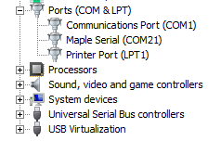
I often get asked about why the USB Serial doesn’t seem to work on Maple mini or generic STM32F103 boards loaded with the STMduino-bootloader.
If you buy a brand new Maple mini, and plug it into your PC or Mac or Linux box. Do not be suprised if you only see a DFU device. This is normal.
Just compile and upload a blank sketch. Even a blank sketch will contain the Serial USB code, and your board should then appear as a “Maple Serial” device.
There is a common missconception that the STM32duino-bootloader, and the older Maple bootloader, contain both DFU (upload) USB support and also “Maple Serial” (USB Serial) functionality. However this is not the case.
Originally when Leaflabs wrote the Maple bootloader (back in around 2012) they tried to include both DFU and Serial functionality, however they found issues with this under Windows. This is because the DFU and Serial functionality requires the use of 2 completely different (built in) drivers in Windows; when the Maple board is only one USB device.
Normally manufacturers create composite USB devices in this case, i.e one USB driver that performs both the DFU and Serial functions. But creation and certification of custom drivers for Windows is non-trivial and expensive. Hence LeafLabs chose to separate the DFU and Serial USB functionality, so that only the DFU driver is used when the bootloader is running and only the Serial driver is used when the Arduino sketch is running.
This method allows the use of 2 separate Windows drivers – both of which come as standard on all Windows installations.
Although the functionality of both DFU and USB Serial could have been included in the bootloader, it would make the bootloader and sketch core code (libmaple) more complicated, as the sketch would need to communicate with the bootloader in order to send and receive serial data.
So Leaflabs chose to go with the simpler option of the bootloader only containing the DFU functionality, and for the USB Serial to be compiled as part of the sketch. Although this is the simpler option, its probably the best one, because if the Serial USB support was contained in the bootloader, the amount of additional code to allow the sketch to send and receive Serial via the bootloader would make the overall size of the bootloader and sketch slightly larger.
Sketches do take slightly longer to upload than if they did not contain the USB Serial functionality, but uploads via DFU are generally faster than AVR Arduinos, so this isn’t a serious concern.
Another consequence of splitting the functionality, is that if the sketch crashes, then the USB Serial will also crash, and often the USB Serial device will not appear at all.
And… any board that has been freshly installed with a bootloader, will only appear as a DFU device, because the bootloader checks to see if a valid sketch is in the program (flash) memory, and if not the bootloader continues to stay in DFU mode until a valid sketch has been upload.
==================

Windows driver installation
If you want to upload sketches via USB or to use the USB Serial connectivity, you need to install drivers for the Serial and DFU upload devices.
Please run drivers/win/install_drivers.bat (Windows 7 or newer).
Note. This doesn't actually install new driver files. Windows comes pre-installed with a compatible Serial USB driver and a DFU (device firmware update) driver. However, the built in drivers need to be associated with the USB ID of the Maple serial and DFU devices. The batch file and wdi-simple.exe do the clever stuff to convince Windows that it should use these drivers for the Maple serial and DFU devices.
The Maple DFU device appears after the board is reset.
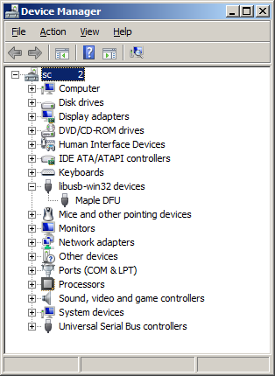
If the board was programmed with a sketch, then the bootloader will start the sketch. The DFU device disappears and the Maple Serial device appears instead as a virtual COM port.
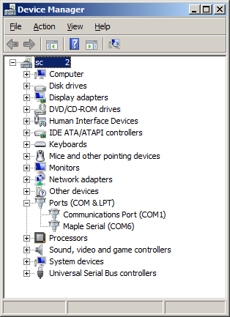

Uploading a sketch

Using Arduino IDE
In Arduino IDE, the first step is to select the appropriate STM32 board from the Tools -> Board menu.
The preferred upload method can be selected in the IDE from Tools -> Upload method.
If you're just starting, you can try the 'blink' sketch. That's a very small sketch and since it makes an LED blink, it's easy to check if it's running or not. You can find it in the menu at File -> Examples -> A_STM32_Examples -> Digital -> Blink.
Currently, there are four supported upload methods:
- STM32duino bootloader
- Serial
- STLink
- BMP (Black Magic Probe)

Upload via STM32duino bootloader
First, you need to ensure you have the drivers for the Serial and DFU (upload) devices installed -- see Installation for instructions.
Also, your STM32 board needs to have the STM32dunio bootloader -- see Burning the bootloader.
If your board does not yet have a sketch running, it appears as a Maple DFU device. This will be used to upload the first sketch.
Once a sketch is running, the DFU is not present, but the Maple Serial device is. Select its COM port from the Tools -> Port menu.
Run 'Sketch -> Upload' in Arduino IDE. After the compilation output you will see the following:
maple_loader v0.1
Resetting to bootloader via DTR pulse
[Reset via USB Serial Failed! Did you select the right serial port?]
Searching for DFU device [1EAF:0003]...
Assuming the board is in perpetual bootloader mode and continuing to attempt dfu programming...

dfu-util - (C) 2007-2008 by OpenMoko Inc.
This action is accompanied by a beep sound and the on-board LED will start blinking. The upload tool ('maple_loader') will upload the generated binary file to the board.

Manual reset
If you cannot hear any beep sound nor see the LED of the board blinking, the following message may appear:
Couldn't find the DFU device: [1EAF:0003]
This indicates that resetting the board into bootloader DFU mode was not successful. You should manually reset the board when the first text in red is printed in the IDE output window.
If you don't do this within 3 seconds, the upload will fail, and you will have to repeat the upload procedure. Under Linux the timing may be very sensitive. It seems that you want to release the reset button to enter the fast blink upload mode just before the compilation finishes. It may be useful to use the Arduino IDE 'Sketch -> Verify/Compile' action so that it will compile before trying an upload, because the first compile can be slow, even for something as simple as a blink sketch. Then when you try to upload, it will compile again, but much faster and with more predictable timing to allow you to coordinate the release of the reset button.

Upload via Serial
For this method an additional USB to Serial adapter is needed.
A full description of the upload process is available in the video Roger posted here: [1]
Basically it boils down to these steps.
- Ensure that the serial adapter is using 3.3 Volt (or else, that the Tx/Tx pins of the target device are 5 Volt tolerant).
- Make sure you have installed a working driver for the serial adapter.
- Connect power, ground, and Tx/Rx pins of the serial adapter to your STM32. Adapter Tx goes to STM32 USART1 Rx (PA10), Rx goes to STM32 Tx (PA9).
- Plug in the serial adapter to USB. Take not of the serial port it's using.
- In Arduino IDE, select Tools -> Upload method -> Serial and set Tools -> Port -> [your serial port].
- Place your STM32 in 'native bootloader' mode by changing the BOOT0 jumper position to "1" and resetting the board.
- Upload the sketch in Arduino IDE: Sketch -> Upload.
- Change BOOT0 jumper back to "0" and reset the board.
Beware! When uploading in this way, the sketch may be uploaded to the start of the STM32's flash memory. If an STM32duino bootloader is installed there, this may get overwritten.

Upload via ST Link
For this method you have to use a STLink V2 [2] device connected to the PC over USB and to your board via the SWD interface.
For another guide to uploading by ST Link comptatible devices see the Github wiki: [3]
Also, be sure that the necessary driver for Windows is installed and the STLink adapter is updated to the latest firmware (version V2J27S6 or later).
You can use the official ST-Link V2 programmer or one of the many clones.
There are several versions of the cloned ST-Link V2 adapters available, they may break out different numbers of pins, depending on the manufacturer, but all should have at least the pins listed below.
We only need three pins for basic programming and debugging of the STM32FXXX devices, (four if you are powering the board from the programmer) using Serial Debug Wire (SWD).
Connect to following pins of the programmer to the corresponding pins on the STM board:
3.3V (Optional) NOTE: Not needed if powering the target board from USB or an external supply.
Check your board schematic to see which pin is best for this.
Pin 1 (and optionally pin 2) of the 20 way JTAG/SWD header, if fitted are designated as VCC
which should be 3.3V on the board, but test with a multimeter if you are in any doubt.
Avoid sending 3.3V to the target board if using an external supply or you may damage the board, programmer, USB port or external supply.
GND - Pin 4,6,8,10,12,14,16,18,20 of the 20 way header if fitted, or any other available GND pin.
NOTE:If your board has a separate analog and digital GND, use the digital GND.

SWCLK (PA14) - Pin 9 on the 20 way header if fitted. aka JTCK/SWCLK/PA14
SWDIO (PA13) - Pin 7 on the 20 way header if fitted. aka JTMS/SWDIO/PA13
After a successful build process, the IDE outputs something similar to the following message:
STM32 ST-LINK CLI v2.1.0
STM32 ST-LINK Command Line Interface

ST-LINK SN : [serial_numer_of_the_adapter]
ST-LINK Firmware version : V2J27S6
Connected via SWD.
SWD Frequency = 1800K.
Connection mode : Normal.
Device ID:0x410
Device flash Size : 64 Kbytes
Device family :STM32F10xx Medium-density

Loading file...
Flash Programming:
File : C:\Users\[user]\AppData\Local\Temp\buildbf9409c1ae369e3d22510a2824c2116e.tmp\Blink.ino.bin
Address : 0x08000000
Flash memory programming...
±±±±±±±±±±±±±±±±±±±±±±±±±±±±±±±±±±±±±±±±±±±±±±±±±± 0%
0%ÛÛÛÛÛÛÛÛÛÛÛÛÛÛÛÛÛÛÛÛÛÛÛÛÛÛÛÛÛÛÛÛÛÛÛÛÛÛÛÛÛÛÛÛÛÛÛÛÛÛ 100%
Flash memory programmed in 0s and 594ms.
Programming Complete.

MCU Reset.

Application started.
If you get the message:
No target connected
Unable to connect to ST-LINK!
This means that the ST-Link V2 adapter cannot communicate with the board. In this case check the hardware wires. Or, as alternative, you can also supply the 3.3V to the board only over the adapter, removing the USB cable, if any. Finally, if none of these helps, you should manually reset the board within 3 second after the upload process begins (red text printed in the output window).

Using Eclipse
It is possible to setup a project under Eclipse using the system files of the Arduino environment.
Arduino with Eclipse
The same upload methods are supported as listed above.
The preferred upload method can be picked up by clicking the current project in the Project Explorer window and selecting via menu: File -> Properties -> Arduino. Acknowledge your selection by clicking "Apply", then "OK".

